

**Placement Empowerment Program**

***Cloud Computing and DevOps Centre***

# Setting up a virtual machine (VM) in the cloud using AWS

Name: MADHUMETHRA AP

Department: IT

# 

**Introduction**

Cloud computing has revolutionized the way IT infrastructure is managed, offering scalable and cost-effective solutions. One of the fundamental services provided by cloud platforms like AWS, Azure, and Google Cloud Platform (GCP) is the ability to deploy Virtual Machines (VMs). These VMs allow users to run applications, test environments, or host services without the need for physical hardware.

### **Overview**

In this guide, we will walk through the process of setting up a free-tier virtual machine on a cloud platform. You will learn how to:

Create a cloud account (AWS, Azure, or GCP).

Deploy a Linux-based virtual machine using the cloud provider’s interface.

Connect to the VM securely using SSH.

Verify the connection and ensure the VM is operational.

Each cloud provider offers a free-tier that allows users to create a basic VM without incurring charges, making this a great way to get hands-on experience with cloud computing.

**Objectives**

By the end of this guide, you will be able to:

Create a cloud account with AWS, Azure, or GCP.

Launch a virtual machine using a free-tier eligible instance.

Configure networking and security settings to allow remote access.

Use SSH to connect to the VM securely.

Verify system functionality and execute basic commands.

**Importance**

Successful creation of a cloud-based virtual machine (VM) on AWS, Azure, or GCP using free-tier resources.

Securely connect to the VM via SSH, demonstrating your ability to access and manage a remote server.

Verify system functionality by running basic commands, confirming that the VM is operational.

Gain hands-on experience in cloud computing, including setting up infrastructure, managing access controls, and interacting with remote servers.

Establish a foundation for advanced cloud-based tasks, such as deploying applications, configuring web servers, or automating cloud workflows.

**Step-by-Step Overview**

Step 1

AWS (Amazon Web Services)

Steps to create a Free-tier VM (EC2 instance):

Sign Up for AWS Free Tier:

Step 2

Go to AWS Free Tier and sign up for an AWS account if you don’t have one.

You’ll need a credit card, but you won't be charged for services that fall under the free tier.

Launch EC2 Instance:

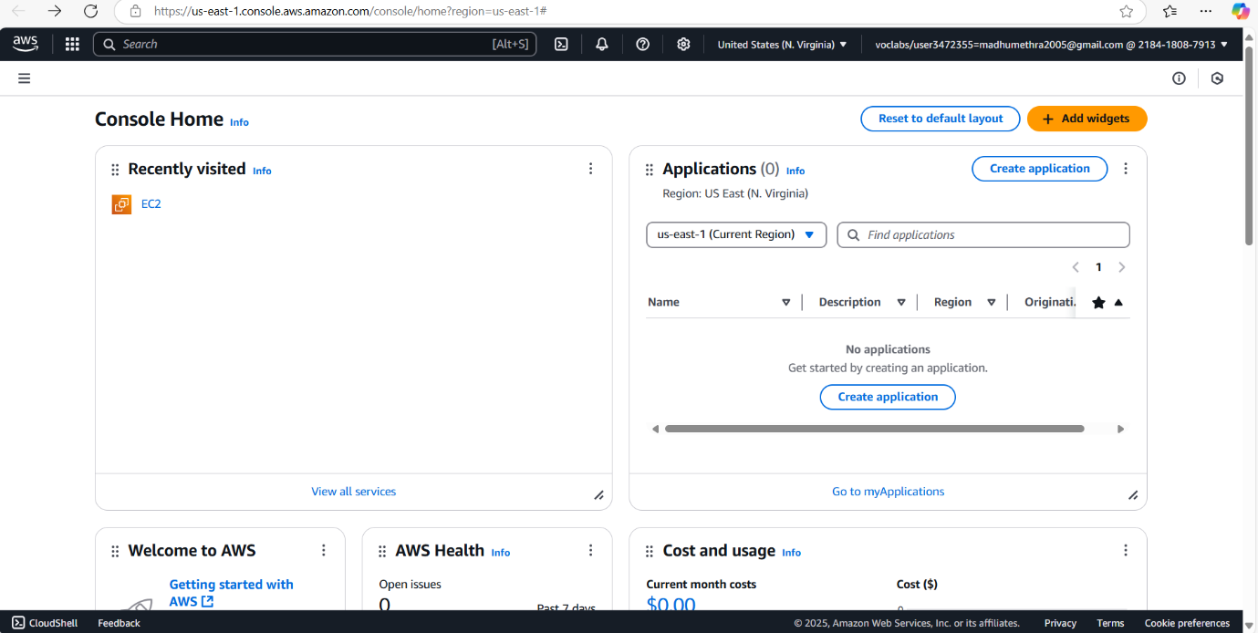

Step 3

After logging in to the AWS Management Console, search for “EC2” in the search bar and click on it.

Click on “Launch Instance” to create a new VM.

Choose an AMI (Amazon Machine Image): Select a free-tier eligible image like “Amazon Linux 2” or “Ubuntu Server”.

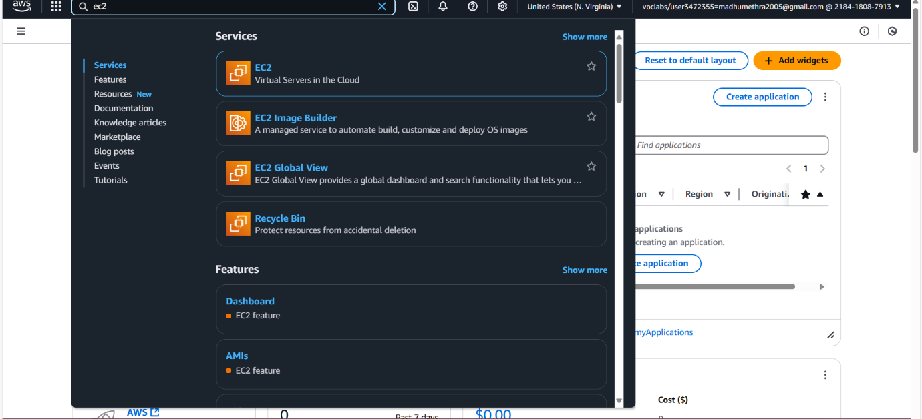

Step 4

Choose an Instance Type: Select the “t2.micro” instance type, which is free-tier eligible.

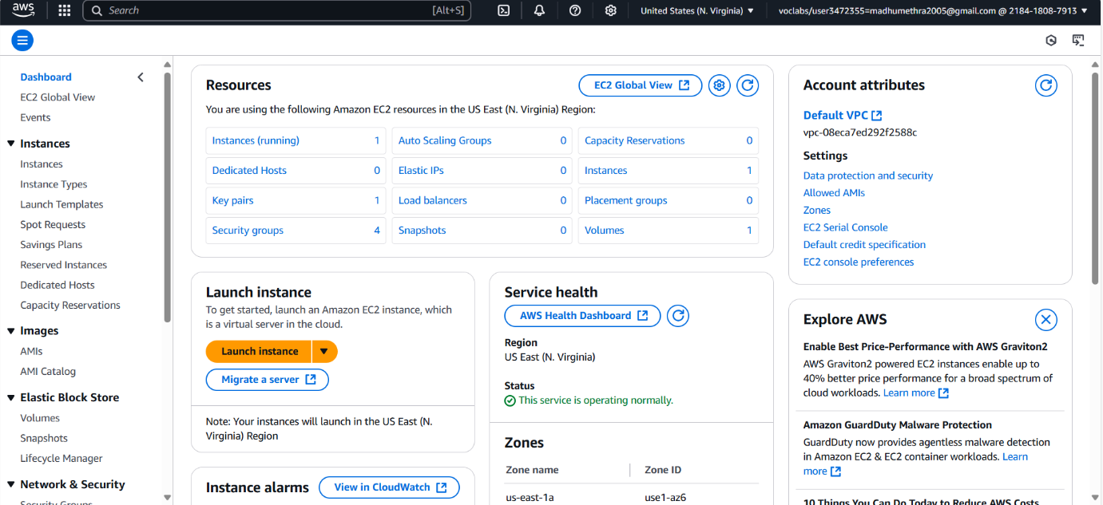

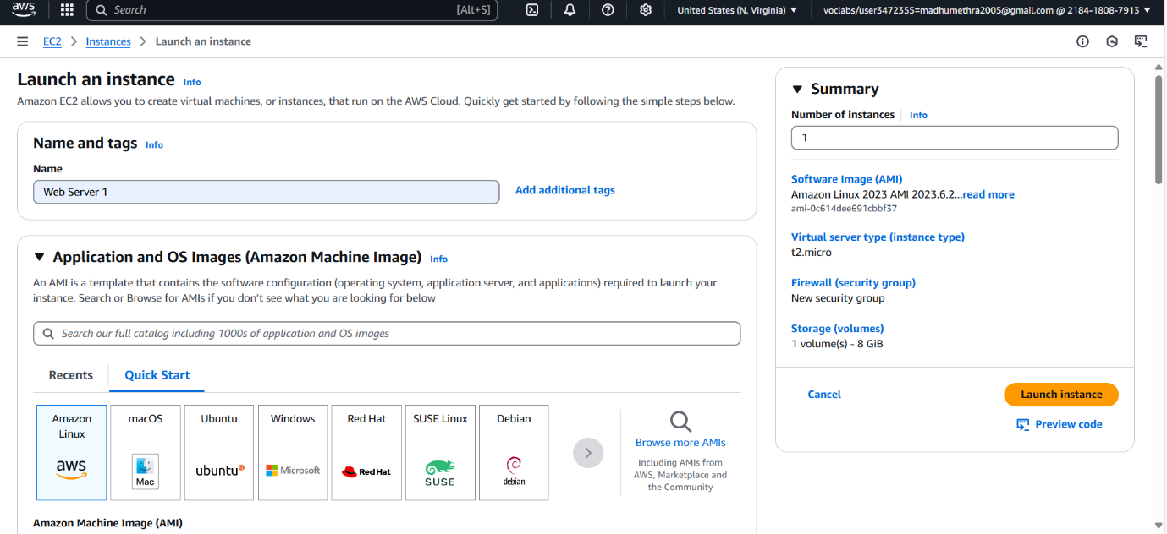

Step 5

Configure Instance: Use the default configuration for simplicity, but you can change settings like security groups later.

Configure Security Group: Allow SSH (port 22) for Linux or RDP (port 3389) for Windows if you want remote access.

Launch: Review your settings and click "Launch". You'll need to create or use an existing key pair for SSH access.

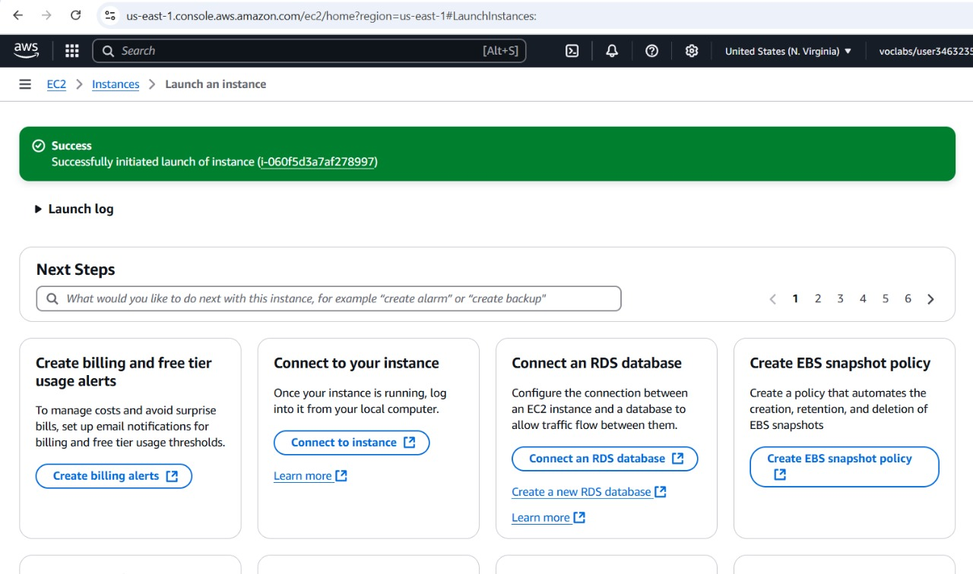

**Output**

The outcome of setting up a virtual machine (VM) in the cloud can be summarized as follows:

On-demand computing resources: You gain access to scalable computing resources (CPU, memory, storage) that you can provision and deprovision as needed, avoiding the need to invest in and maintain physical hardware.

Flexibility and scalability: You can easily resize your VM's resources (e.g., increase RAM or storage) as your needs change. You can also easily spin up multiple VMs if required.

Cost-effectiveness: Cloud VMs often operate on a pay-as-you-go model, allowing you to pay only for the resources you consume. This can be more cost-effective than owning and maintaining physical servers, especially for fluctuating workloads.

Increased agility: Setting up a VM in the cloud is typically much faster than procuring and setting up physical hardware. This allows you to quickly deploy applications and services.

Improved availability and reliability: Cloud providers typically offer redundant infrastructure and features like automatic backups and disaster recovery, which can improve the availability and reliability of your applications.

Accessibility: You can access your cloud VM from anywhere with an internet connection, making it convenient for remote work and collaboration.

Simplified management: Cloud providers often offer tools and services to simplify the management of your VMs, such as monitoring, logging, and patching.

Testing and development environment: Cloud VMs provide an ideal environment for testing and developing applications, as you can easily create and destroy VMs as needed.

Disaster recovery: VMs can be easily replicated or backed up, making them a good solution for disaster recovery planning.